18.67: a) Dividing both sides of Eq. (18.7) by the product RTV gives the result. b) The algorithm described is best implemented on a programmable calculator or computer; for a calculator, the numerical procedure is an interation of

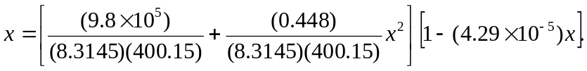

Starting at  gives a fixed point at 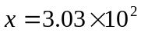 after four iterations. The number density is 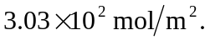 c) The ideal-gas equation is the result after the first iteration, 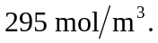The vander Waals density is larger. The term corresponding to a represents the attraction of the molecules, and hence more molecules will be in a given volume for a given pressure.

